

|  |  |  |  |  |  |
| --- | --- | --- | --- | --- | --- |
| Programme | : | **B.Tech.** | Semester | : | **Fall 22-23** |
| Course | : | **CSE3002:**  **Internet and Web Programming Lab** | Slot | : | **L9+L10** |
| Faculty | : | **Dr. M. Premalatha** | Marks | : | **10** |

**Date: 16-08-2022**

**Advait Deochakke**

**20BCE1143**

**Exercise –3**

HTML – **Forms and CSS**

**Note:**

1. **View your registration number in the title bar and snap a screenshot of output along with the title bar.**
2. **Screenshot is required for every modifications of the web page.**

***CSS***

1. Apply styles using **INLINE CSS** to the below table (3 marks)

|  |
| --- |
| **LEARN DATA SCIENCE!** |
| * **Unlimited jobs** * **Best benefits anywhere** * **Call now for an appointment** |



**Code:**

<head>

    <title>20BCE1143 - ex 3</title>

</head>

<body style="background-color: black;">

<table style="border:orange 1px solid">

<tr>

    <td style="background-color:orange"><font style="color:aliceblue; font-family: 'Segoe UI', Tahoma, Geneva, Verdana, sans-serif;">LEARN DATA SCIENCE!</font></td>

</tr>

<tr style="align:center">

    <td>

        <ul style="list-style-type:disc">

        <li style="color:darkslateblue">Unlimited Jobs</li>

        <li style="color:darkslateblue">Best Benefits Anywhere</li>

        <li style="color:darkslateblue">Call now for an appointment</li>

        </ul>

    </td>

</tr>

</table>

</table>

</body>

1. Design a calculator as the image shown below using HTML table, buttons and text box. Create an **external file** called calc.css” using class and ID selector to apply style. Use CSS color, background, and border. Link the “calc.css” file to the “calculator.html” file. Also, use suitable property to change the color of the buttons when mouse over the buttons.

(4 marks)

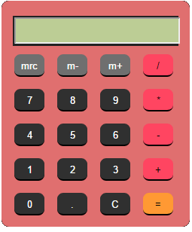

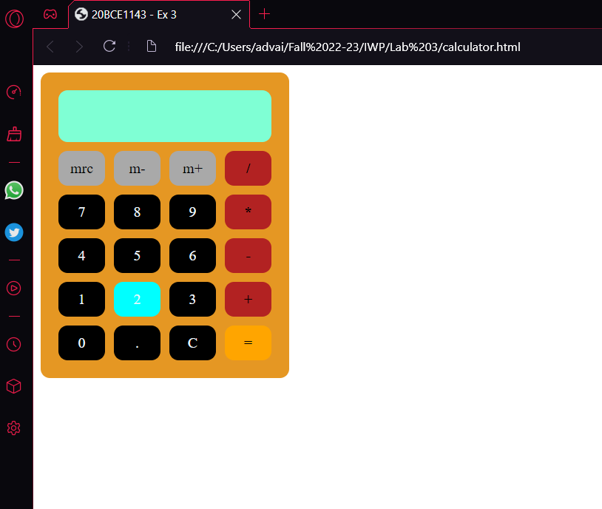

**Code:**

<head>

    <title>20BCE1143 - Ex 3</title>

    <link rel="stylesheet" type="text/css" href="calc.css">

</head>

<body>

    <table>

        <tr>

            <td colspan="4" class="screen">invisible text</td>

        </tr>

        <tr>

            <td class="mstuff">mrc</td>

            <td class="mstuff">m-</td>

            <td class="mstuff">m+</td>

            <td class="operations"><b>/</b></td>

        </tr>

        <tr>

            <td class="vals">7</td>

            <td class="vals">8</td>

            <td class="vals">9</td>

            <td class="operations"><b>*</b></td>

        </tr>

        <tr>

            <td class="vals">4</td>

            <td class="vals">5</td>

            <td class="vals">6</td>

            <td class="operations"><b>-</b></td>

        </tr>

        <tr>

            <td class="vals">1</td>

            <td class="vals">2</td>

            <td class="vals">3</td>

            <td class="operations"><b>+</b></td>

        </tr>

        <tr>

            <td class="vals">0</td>

            <td class="vals">.</td>

            <td class="vals">C</td>

            <td class="equals">=</td>

        </tr>

    </table>

</body>

**CSS:**

body {

    background-color: white;

}

table {

    border-width: 10px;

    border-style: solid;

    border-radius: 10px;

    border-color: rgb(229, 151, 35);

    background-color: rgb(229, 151, 35);

    border-spacing: 10px;

}

td {

    text-align: center;

    color: aliceblue;

    column-width: 30px;

    border-radius: 10px;

    border-bottom: 2px;

    border-color: black;

    padding:10px

}

.vals {

    background-color: black;

}

.screen {

    background-color:aquamarine ;

    color: aquamarine;

}

.operations {

    background-color: firebrick;

    color: black;

}

.mstuff {

    background-color: darkgray;

    color:black;

}

.equals {

    background-color: orange;

    color:black;

}

td:hover {

    background-color: cyan;

}

1. Design a personal webpage (about me) and apply style using **internal CSS** (3 marks)

* Apply rainbow effect to your name
* Descriptions should be in multiple column format

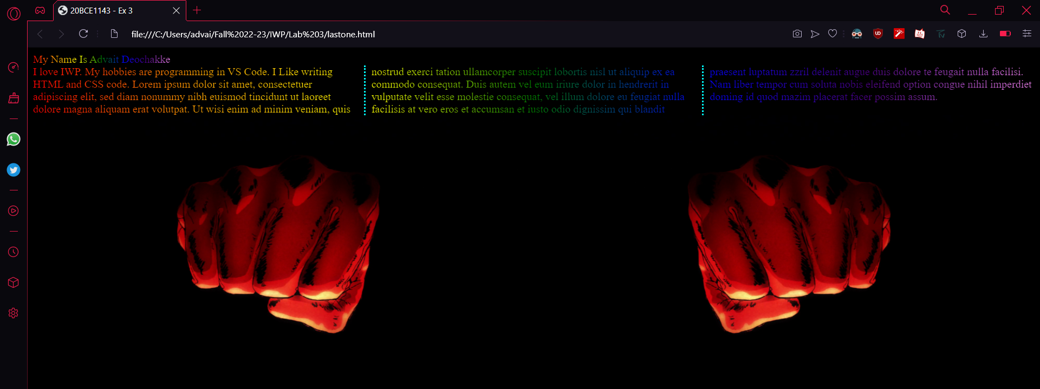

**Code:**

<head>

    <title>20BCE1143 - Ex 3</title>

    <style>

        .iloverainbows {

            background-image: linear-gradient(to left, violet, indigo, blue, green, yellow, orange, red);

            -webkit-background-clip: text;

            -moz-background-clip: text;

            background-clip: text;

            color:transparent;

        }

        body {

            background-color: black;

        }

        div {

            column-count:3;

            column-width:30px;

            column-gap: 20px;

            column-rule-style: dotted;

            column-rule-color: aqua;

        }

        img {

            width: 50%;

            height: 50%;

            -webkit-box-reflect: right;

        }

    </style>

</head>

<body>

    <span class="iloverainbows">My Name Is Advait Deochakke</span>

    <div class="iloverainbows">I love IWP. My hobbies are programming in VS Code. I Like writing HTML and CSS code.

        Lorem ipsum dolor sit amet, consectetuer adipiscing elit,

        sed diam nonummy nibh euismod tincidunt ut laoreet dolore magna aliquam erat volutpat.

        Ut wisi enim ad minim veniam,

        quis nostrud exerci tation ullamcorper suscipit lobortis nisl ut aliquip ex ea commodo consequat.

        Duis autem vel eum iriure dolor in hendrerit in vulputate velit esse molestie consequat,

        vel illum dolore eu feugiat nulla facilisis at vero eros et accumsan et iusto odio dignissim qui

        blandit praesent luptatum zzril delenit augue duis dolore te feugait nulla facilisi.

        Nam liber tempor cum soluta nobis eleifend option congue nihil imperdiet doming id quod mazim placerat facer possim assum.

    </div>

    <img src="C:\Users\advai\wallpaper\anime_x\AnimeX_797140.jpeg">

</body>